INSTRUCTIONS FOR SUBMISSION OF ELECTRONIC FILE TO AGECON SEARCH

Congratulations on the acceptance of your abstract!

Here are the instructions for posting a full-text copy of your selected abstracts on AgEcon Search: Research in Agricultural and Applied Economics. The EAAE Board has decided to use AgEcon Search as a standard tool for making the papers of congresses and seminars available to the research community.

For the 181st seminar, all accepted selected abstracts must be submitted via Converia by Oct, 16th.

If you are not already familiar with AgEcon Search: Research in Agricultural and Applied Economics is an electronic library dedicated to collecting, indexing, preserving, and distributing full-text copies of scholarly research in the discipline of Agricultural and Applied Economics. We invite you to visit us at this address: https://ageconsearch.umn.edu/.

Each paper must have a separate cover page which includes the following information: the title of the paper, the author’(s) name, the affiliation of the author(s), and the name of the seminar. A sample cover page is attached. We suggest that you include a copyright statement at the bottom of this page. You, as author of the paper, retain the copyright of the paper. The following is a sample copyright statement that you may use or adapt for your paper.

Copyright 2022 by [authors(s)]. All rights reserved. Readers may make verbatim copies of this document for non-commercial purposes by any means, provided that this copyright notice appears on all such copies.

The papers on AgEcon Search are posted in PDF format. Name your file with the last name of the first author (i.e. smith.pdf). Be sure to review the PDF file you have created before sending it to verify that text and formulas have transferred correctly. DO NOT SUBMIT A WORD DOCUMENT.

Once a paper is received at AgEcon Search it goes through a verification procedure before it actually appears on the web. If you have any questions about or problems with the submission of your electronic paper, contact eaae181@thuenen.de.

Title of the Extended Abstract

Authors
Author Affiliation and Contact Information

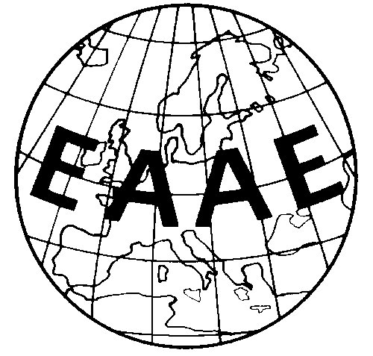

Extended abstract prepared for presentation at the 181st seminar of the EAAE
“Greenhouse gas emissions in the EU agriculture and food sector: potential and limits of climate mitigation policies and pricing instruments”
Berlin, Germany
October 5-7, 2022

Copyright 2022 by [authors]. All rights reserved. Readers may make verbatim copies of this document for non-commercial purposes by any means, provided that this copyright notice appears on all such copies.

